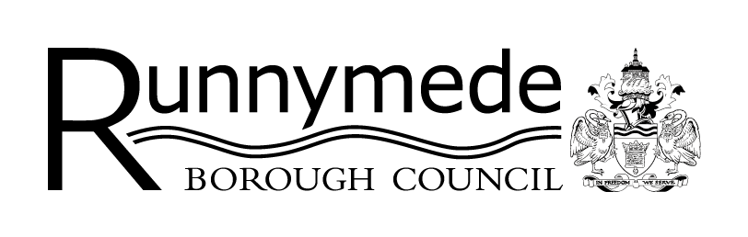

Draft Runnymede Pitch and Plot
Allocation Scheme for Gypsies, Travellers
and Travelling Showpeople
Supplementary Planning Document (SPD)
Representation Form

Public Consultation period from Wednesday 5 June to 11.59pm on 31 July 2024

Further information about the consultation can be found at: www.runnymede.gov.uk/say/consultations-surveys

Please email completed forms to: planningpolicy@runnymede.gov.uk or send them by post to: Planning Policy Team, Runnymede Borough Council, Runnymede Civic Centre, 40-42 Station Road, Addlestone KT15 2AF

When submitting the form, please indicate whether you would like to be notified of when the final version of the SPD is adopted.
PART A – CONTACT DETAILS

Please note that in order to show that the consultation was carried out properly, a summary of all representations received will be available for the public to view and cannot be treated as confidential. Data will be processed and held in accordance with the Data Protection Act 2018 and the General Data Protection Regulations 2018. The Council’s data protection policy can be found at: www.runnymede.gov.uk/information-data/general-data-protection-regulation.

PART A – CONTACT DETAILS

 | 1. | Personal Details | 2. | Agent Details (if applicable)
Title
First Name
Last Name
Job title (where relevant)
Organisation
(where relevant)
Address Line 1
Address Line 2
Address Line 3
Address Line 4
Post Code
Telephone number
Email address (where relevant)

PART B – YOUR REPRESENTATION
Note: If you wish to comment on more than one paragraph or section of the document please use another form.

Name or Organisation

3. | To which part of the Supplementary Planning Document does this representation relate?
Whole document
Specific section |  |  | Paragraph number |  | Appendix

4. | Your Representation(s):  Please set out your comments here – extend the box if necessary
5. | If you would like to amend or add new text, please put forward your suggested revised wording below. Please be as precise as possible.  Detailed comments may be provided on separate sheets, if necessary.

Please note that your representation should cover precisely all the information necessary to support your representations, as there will not normally be a subsequent opportunity to make further representations. All representations will be held by the Council in accordance with the Data Protection Act. Your name, organisation (if relevant) and representations may be made available to the public, in council committee papers and as otherwise considered appropriate by us. Your personal data i.e. postal addresses, emails and telephone numbers will not be shared with the public.
Date

Privacy notice

Thank you for responding to the consultation.

If you are on our planning policy mailing list, you have the right to withdraw your consent to receive notifications at any time. You can do so by emailing planningpolicy@runnymede.gov.uk stating you wish to be removed from the mailing list.

We take the security of your data seriously. The organisation has internal policies and controls in place to try to ensure that your data is not lost, accidentally destroyed, misused or disclosed, and is not accessed except by its employees in the performance of their duties. Information about the collection, processing, access to and protection of personal data, and your legal rights in respect of the personal information we collect from you, is described in our full Council Corporate Privacy Notice, available on our website at: www.runnymede.gov.uk/council-local-democracy/privacy-statement.

