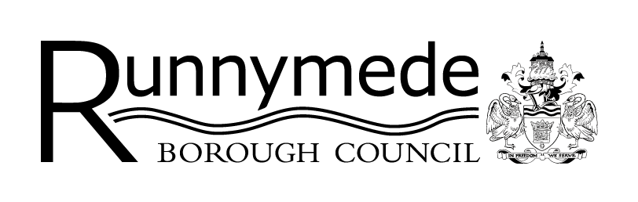
Runnymede Borough Council
Infrastructure Delivery Schedule
Proforma

Our Infrastructure Delivery Schedule (IDS) records all those projects we identify as being required to support development in our Borough, and is a key document for informing the prioritisation and spending of developer contributions – including the Community Infrastructure Levy (CIL). It is therefore important that the information relating to the projects featuring on the IDS is kept up to date.

The Council has collected CIL since March 2021, which charges a levy on certain new developments, payable on commencement. The CIL receipts collected must be used to help fund infrastructure required to support the growth of the Borough. CIL cannot fund all the required infrastructure, but it is instead designed to be one source of revenue which can then lever in additional match funding. We undertake an annual process – the CIL Funding Programme - to identify which of the projects on the IDS are most suitable to receive CIL funding in the following financial year.

We encourage you to complete this proforma for each of your infrastructure projects. Use of the form is not a requirement, but it is designed to help you understand which projects are and are not suitable for inclusion on the IDS; and to capture all the information officers need to update existing projects / include new projects on the IDS.

For entirely new schemes, please complete a blank proforma. For projects which already appear on the IDS, please complete relevant parts of the form with the latest information to give the most up to date position for your project (including dates of any completed projects which can be removed from the IDS). Please complete a separate proforma for each of your infrastructure projects.

Detailed guidance regarding the IDS Update is available at 2030 Local Plan Evidence Base documents – Runnymede Borough Council.

Please return completed form to planningpolicy@runnymede.gov.uk.

- Project Details

Project name/title:
Proposed location:

Town / village etc.

Project aim and description:

Brief description of the proposal, its overall project aim, and what you are hoping it will achieve
Does the project propose?  Please tick all those that apply. | ☐ Provision of new infrastructure  ☐ Improvement of existing infrastructure  ☐ Replacement of existing infrastructure  ☐ Operation  ☐ Maintenance
Is the project already on the IDS? | ☐ Yes  ☐ No
Has the project already been started? | ☐ Yes  If yes, please provide a brief update on how the project is progressing, providing likely timescales for completion:  ☐ No
Has the project been completed? | ☐ Yes – completion date: [there is no need to continue with this form]  ☐ No

- Contact Details

Organisation / Service Area Name:
Project Lead / Contact Name:

Email address:

Contact number:
Project partners (if applicable):

- Identifying the Strategic Need & Benefits

Does the project meet a local need or demand that has arisen or been exacerbated as a result of new development?

Please explain what need or demand has arisen as a result of new development.
How would the project support or enable growth or planned development in Runnymede?

Details of why this project is required to support new development. Please provide details of any specific development proposals, sites or growth which would be supported, enabled or unlocked by the project.
Is the project identified within a relevant local strategy / policy? | ☐ Yes  ☐ No
Please tick those that apply and provide any relevant strategy / policy details: | ☐ Runnymede 2030 Local Plan  ☐ Surrey County Council Local Transport Plan  ☐ Surrey Infrastructure Plan  ☐ Runnymede Local Cycling and Walking Infrastructure Plan  ☐ Runnymede Green Infrastructure Strategy  ☐ Runnymede Corporate Business Plan  ☐ Runnymede Climate Change Strategy & Action Plan  ☐ Runnymede Empowering our Communities Strategy  ☐ Runnymede Economic Development Strategy  ☐ Runnymede Health & Wellbeing Strategy  ☐ Runnymede Asset Management Strategy & Policies  ☐ Runnymede Sustainable Fleet Management Strategy  ☐ Runnymede Electric Vehicle Strategy  ☐ Masterplan / Development Brief  ☐ Other (please state below)
 | Other:
Does the project meet at least one of the Runnymede Borough Council’s Corporate Priorities 2022-2026?  Please tick all those that apply  LINK to Council Priorities | ☐ Corporate Business Plan 2022 – 2026: sets out priority areas of work including services required by law to deliver.  ☐ Climate Change: to play a key role in creating a greener environment and effective response to climate change.  ☐ Empowering our Communities: to support groups and societies within initiatives to strengthen their communities and to represent and advocate for our residents’ interests.  ☐ Health & Wellbeing: to improve the health and wellbeing of our residents, working in partnership with the NHS and other stakeholders.  ☐ Economic Development: to support sustainable growth in the local economy.
 | Please provide brief details about how the project will help meet the Council’s corporate priorities:

What benefits will the scheme deliver to the local/wider area? | ☐ Economic improvements  ☐ Social improvements  ☐ Environmental improvements
 | Explain the benefit(s) in more detail:
What geographic area will the project benefit? | ☐ Neighbourhood / local  ☐ Town / village  ☐ Borough-wide  ☐ Cross-boundary / beyond
 | Please provide details:

- Deliverability

When can the infrastructure be delivered? | ☐ Within 1-2 years (short-term)  ☐ Within 3-5 years (medium-term)  ☐ Over 5 years (long-term)  ☐ Unknown
 | Please provide details i.e. expected commencement date and completion date:
Which organisation(s) will be responsible for delivering the infrastructure?
If relevant, has any work been carried out to assess the feasibility of the project?

- Project Costs & Funding

What is the indicative cost of the project?
Please complete the table below with as much detail as possible, including, where known, a breakdown of different elements of the scheme.
Project Item | Amount (£)
TOTAL PROJECT COSTS

What are the sources of funding identified?

Please give details of sources of funding identified to deliver the project, which may or may not include CIL funding. This includes your own capital funding/resources.

Source of funding (description) | Status (Secured / Not Secured) | Amount (£)

Are you aware of other available sources of funding that the Council may hold, such as S106 funding, that may be suitable for the project? Please provide details:

Date form completed

Thank you for completing this form. Please return to planningpolicy@runnymede.gov.uk.

Privacy notice

We take the security of your data seriously. The organisation has internal policies and controls in place to try to ensure that your data is not lost, accidentally destroyed, misused or disclosed, and is not accessed except by its employees in the performance of their duties. Information about the collection, processing, access to and protection of personal data, and your legal rights in respect of the personal information we collect from you, is described in our full Council Corporate Privacy Notice, available on our website at: www.runnymede.gov.uk/council-local-democracy/privacy-statement.

Please note that information provided to the Council may be subject to disclosure under the Freedom of Information legislation

